**Task 7**

**Git & Github**

**1. Create a new repository in github.**

New repository created in github and given the link below.

https://github.com/Dhivyashreee/Task7.git

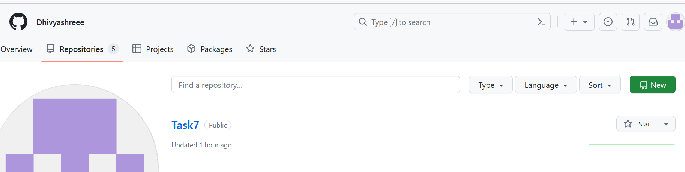

**2. Use the init command to create a Git repository in that directory.**

**3. Observe that there is now a .git directory.**

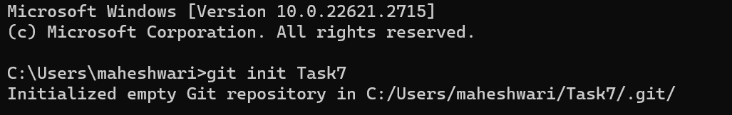

**4. Create a README file.**

**5. Look at the output of the status command, the README you created should appear as an untracked file.**

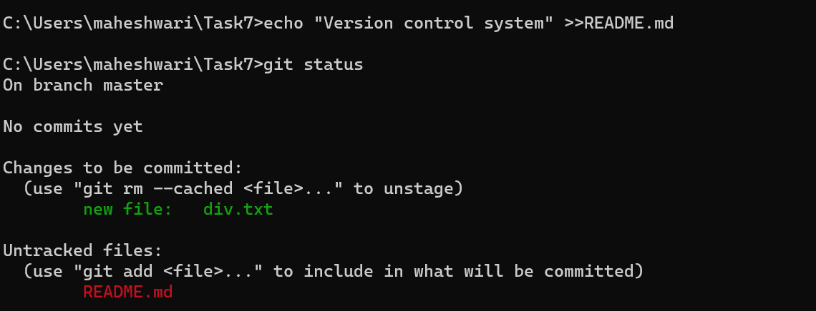

**6. Use the add command to add the new file to the staging area. Again, look at the output of the status of the command.**

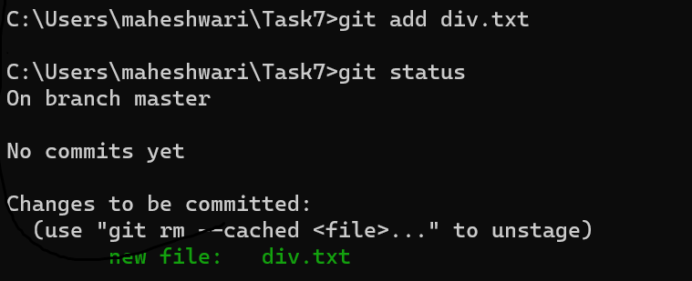

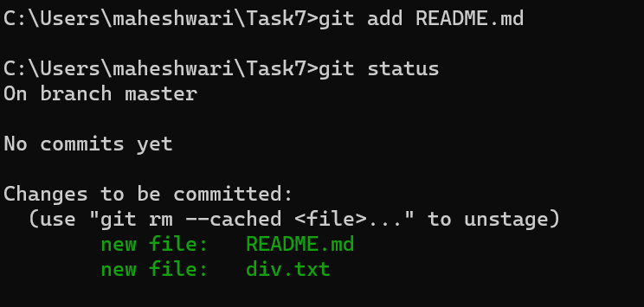

**7. Now use the commit command to commit the contents of the staging area.**

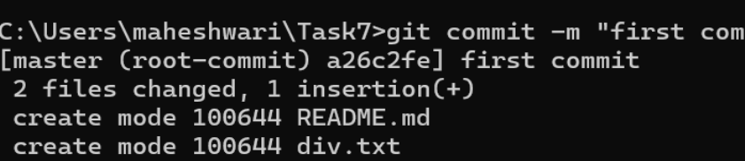

**8. Create a directory and add a couple of files to it.**

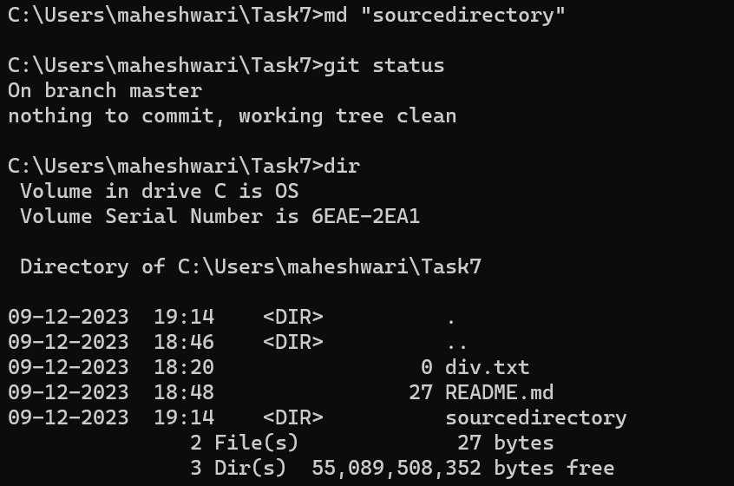

9. Use the add command, but name the directory not the individual files. Use the status command . See how both the files have been staged. Commit them.

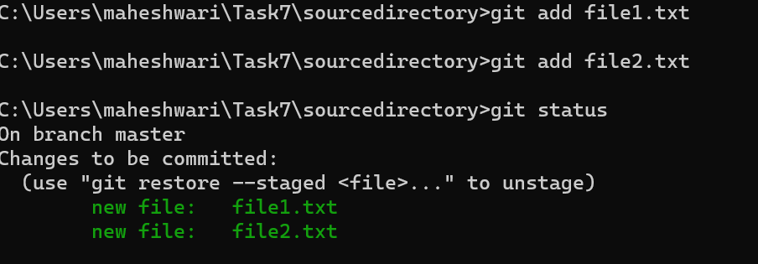

**10. Make a change to one of the files. Use diff command to view the details of the change.**

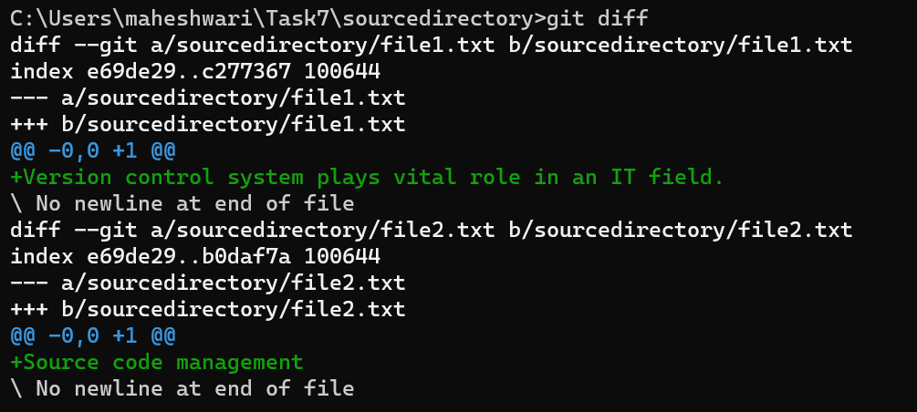

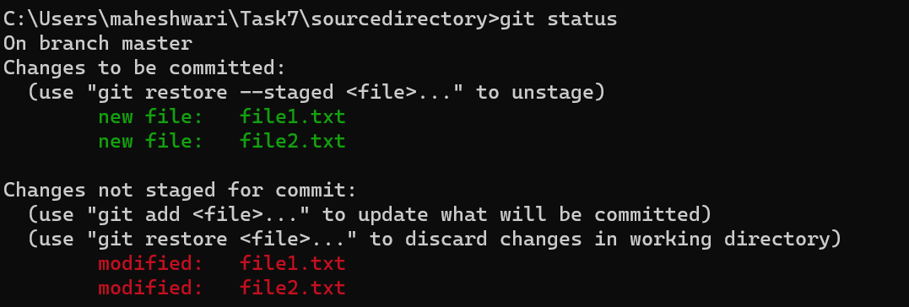

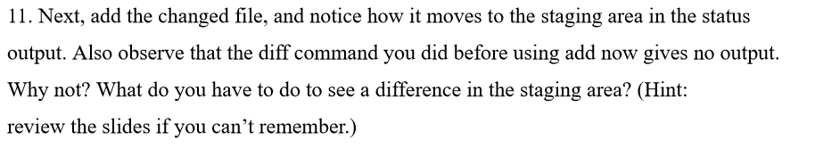

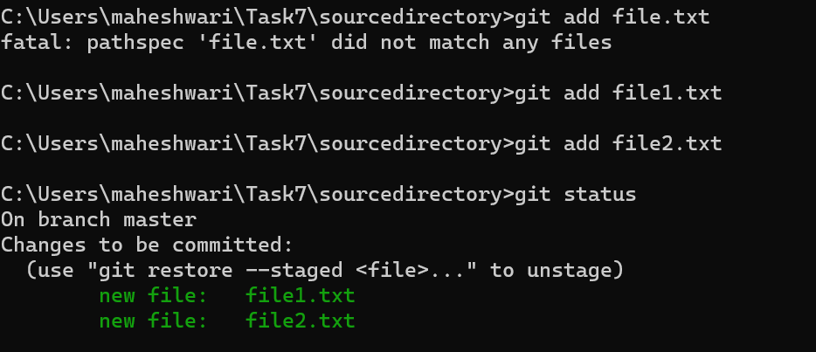

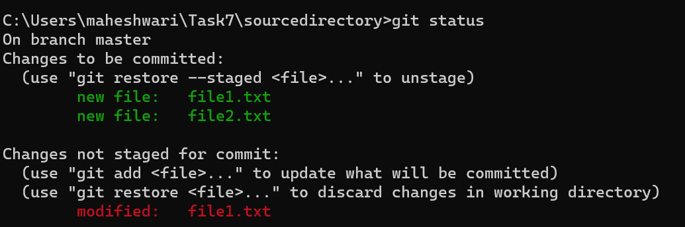

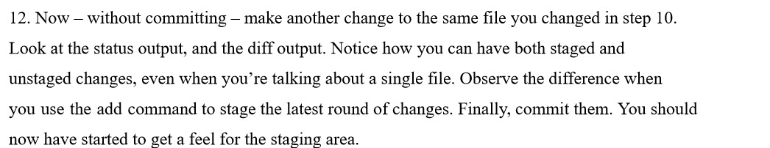

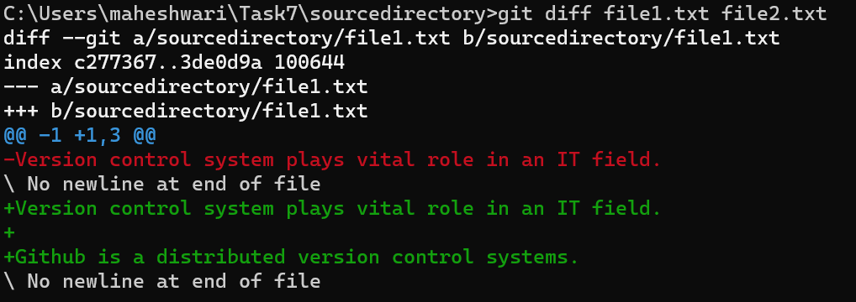

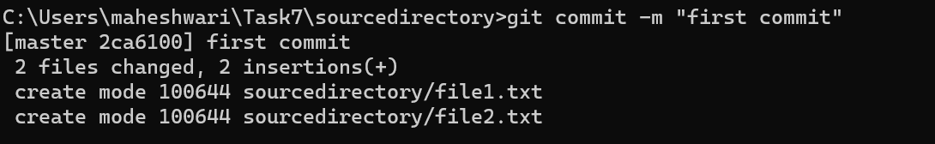

**13. Use log command in order to see all of the commits you made so far.**

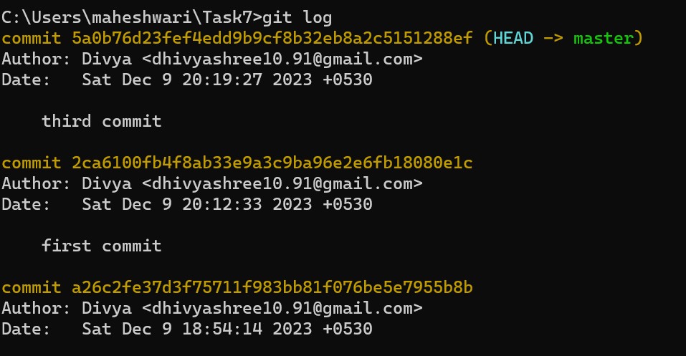

**14. Use the show command to look at an individual commit. How many characters of the common identifier can you get away with typing at a minimum?**

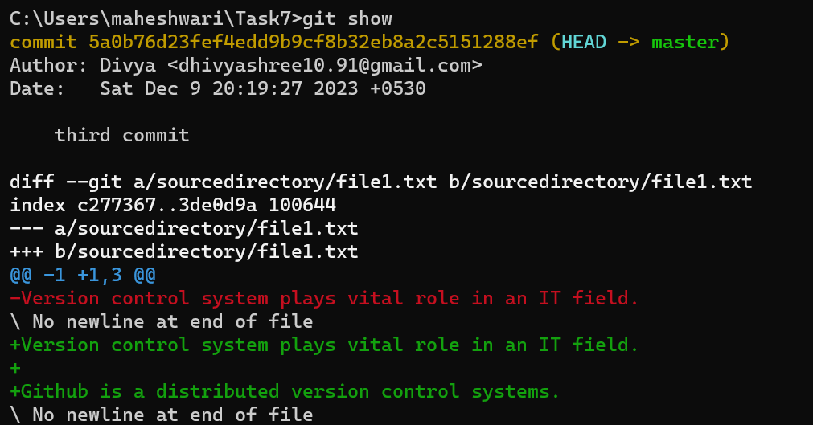

**15. Make a couple more commits, at least one of which should add an extra file.**

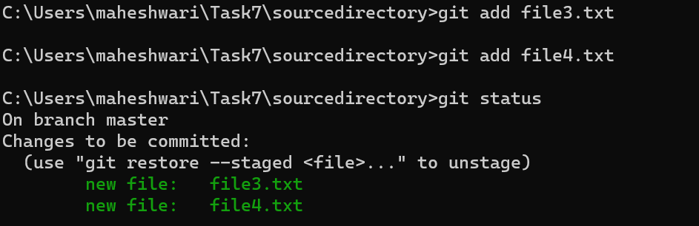

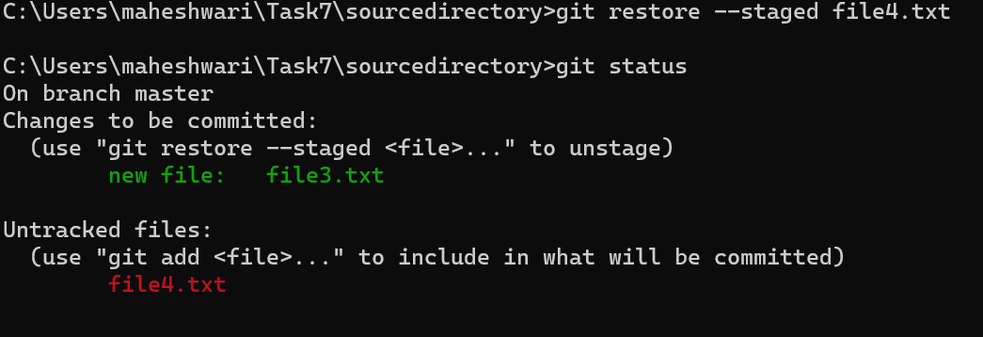

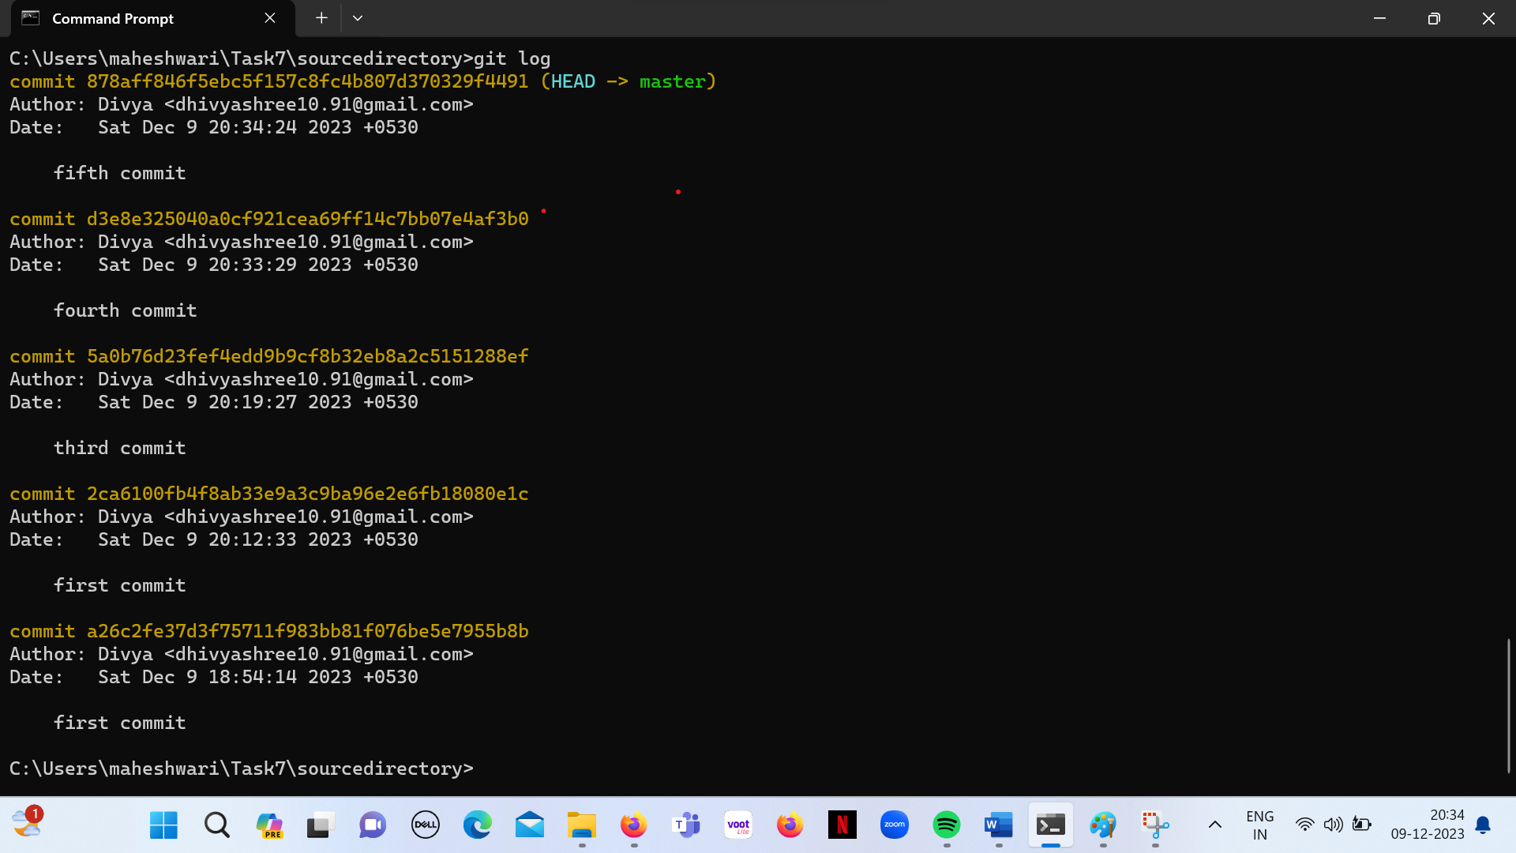

**Local directory files pushed successfully to the remote repository in github.**

